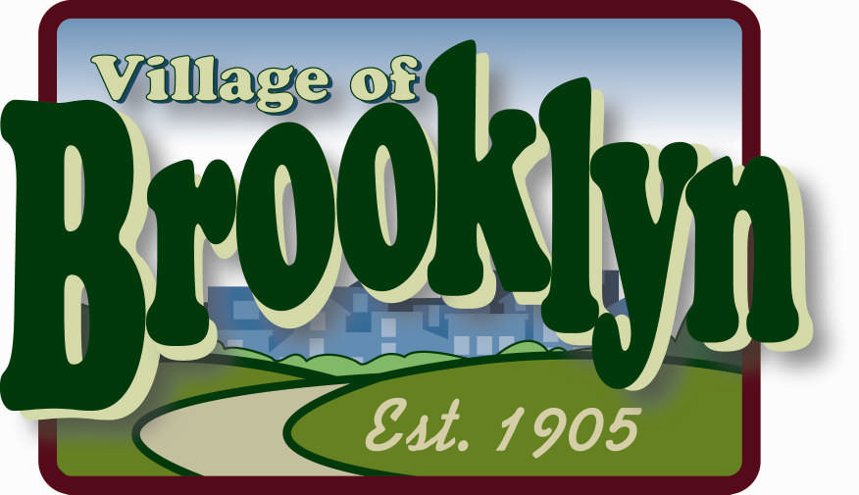

VILLAGE OF BROOKLYN
APPLICATION FOR SPECIAL EVENT PERMIT
(For events on Village property with over 100 participants)

Public/special events are governed by village ordinances and organizers are responsible for all necessary permits, trash and litter pickup, and for damage to any property, as well as possible billing for village services. The organization/organizer agrees to be responsible for the supervision of the event and conduct of persons present. A fee of $25.00 and a deposit of $250.00 will apply, except for local non-profit organizations. Additional fees may be charged for damage to grounds, buildings, and/or failure to pick up litter generated from the event.

NAME OF APPLICANT/ORGANIZATION:

Applicant/Organization Name:
Address: Contact name:_______________________________________________________________
Phone: ___________________________________________________________________________

Email:____________________________________________________________________________

EVENT INFORMATION:

Name/Description of Event___________________________________________________________

Location of Event:__________________________________________________________________
(MUST attach a detailed map or diagram of event, including specific layout)

Date(s) of Event: ___________ Time of Requested Use: ___________
Estimated Attendance: ______________
*******************************

I / We do hereby hold harmless and indemnify the Village and its
Officers, Agents, and Employees against any loss, cost, expense, injury, damage or liability incurred by
reason of any personal injury or property damage sustained by any person, caused or resulting from the
issuance of this permit.

Date:_____________ Applicant Signature:_

- Does the event require street to be closed?  If Yes – Which street(s) and when are you requesting them to be closed?  Street____________________________________________________  Date/Time________________________________________________  NOTE: Application shall include copy of approve permit from the State of  Wisconsin for any parades or special events occurring on a state highway | YES | NO
- Will the event be held in a Village Park or utilize a park facility?  If yes, circle one – Legion or Smithfield | YES | NO
- Do you need extended park hours?  If yes -- indicate desired time______________ | YES | NO
- Do you require any special parking signs?  If yes – please indicate what type and where:____________________ | YES | NO
- Will you need fencing or barricades?  If yes – include what type of fencing/barricades on separate sheet | YES | NO
- Will alcoholic beverages be served/sold?  If yes – you must either amend your current Class B licenses or you must  obtain a Temporary Class B Permit (Picnic Beer Permit), subject to the  requirements. Forms obtained from Village Clerk. | YES | NO
- Will the event use a tent?  If yes – location and size of tent ______________________________  (attach diagram/sketch)  How will tent be anchored (stakes/cement barriers)__________________ | YES | NO
- Will there be a need for additional refuse or recycling containers?  If yes – applicant will be required to organize and obtain dumpster  facilities at applicant expense | YES | NO
- Will any fireworks or pyrotechnic devices be used during the event?  If yes- Fireworks permit is required – Forms from Village Clerk | YES | NO
- Do you plan to provide portable toilets?  NOTE: Ratio of 1 to 100 or 1 to 50 for alcohol infused events | YES | NO
- Will there be the use of loudspeakers or amplifying devices?  If yes – what type of amplifying devices?_____________  Proposed use (i.e., live band/disc jockey):_________________ | YES | NO
- Do you have the correct level of insurance for special event?  Village of Brooklyn requires a minimum of $1 million Liability policy, rider  should be attached to this application and list Village of Brooklyn as  additional insured | YES | NO
- Does your event require additional security?  If yes – you will need to contract with a private company and report the  name and contact person to the Village of Brooklyn | YES | NO

Please attach any additional documents for consideration

Department | Comments
PW

Police

APPROVAL
This application has been reviewed by Public Works and Police Department. Subject to the payment of any fees and the receipt of proof of comprehensive general liability insurance naming the Village of Brooklyn as an additional insured, the Village Board approves this application.
DATE:___________________________________

Public Works:______________________________ Police:_________________________________

President:__________________________________Trustee:________________________________

Trustee:___________________________________Trustee:________________________________

Trustee:___________________________________Trustee:________________________________

Trustee:___________________________________

DATE FEE PAID: ________
DATE PROOF OF INSURANCE RECEIVED: _______
DATE PRIVATE SECURITY INFORMATION RECEIVED: (If applicable)_______

